Joseph Boi-Ukeme (101053347) and Ngozi Silas Echegini (101032933)

3D Oil spill modelling

methodologies for discrete events modelling and simulation

November 23, 2017

**INTRODUCTION**

Oil spills that occur during exploration and production of crude oil in coastal waters can have devastating effects on the environment, aquatic life and even human life. It is important to study the way in which these spills propagate on coastal waters to ensure that in situations when these spills can not be avoided, appropriate plans could be made using data from modelling and simulation to mitigate the effects.

When oil spills on the surface of coastal waters, it disperses due to the concept of conservation of mass. It can also be carried along the surface of the water body due to the effects of wind currents and/or water current. Oil may mix with sea water and have a higher density causing it to sink towards the sea bottom. Hence, the movement of an oil spill can be very complex depending on the condition of the water body. This project models the behaviour of an oil spill on coastal waters using CellDEVS.

**MODEL DESCRIPITION**

In the implementation of the model being described in this report, the model is designed to be a 3-dimensional model called “oilSpill” and the cell space is 100x100x3. This is 3 planes with each plane representing a certain depth, the surface (layer 0), 10m below the water surface (layer 1) and 20m below the water surface (layer 2). Different cases of the model would be analysed, and the final model would be a combination of these cases.

**Highlights:**

* Maximum mass of crude oil that can occupy a cell is 790kg
* A cell with a value of 2000kg means that sell is occupied by coastal vegetation
* A cell with 0kg means the cell has 0kg mass of oil and hence completely occupied by water.
* Oil spreading in this model is studied based on surface movement through conservation of oil mass and wind/water currents, and vertical downward movement of the oil because of the mass gained when oil and water have mixed.
* In various equations for oil spreading the constants m = 0.098 and d = 0. 0176

**Case 1. 2D oil spreading without wind and current on surface**

Fig. 1 represents a portion of the cell space under study. Each plane contains 10,000 cells (100*100). One can think of each cell as a small fraction of the water body which is occupied by either water (0 oil) or Crude oil (790) or a mixture of both oil and water (Greater than zero but less than 790). All mass values are in Kilogram. The cell space has a Moore neighborhood of 9 cells (including itself) see figure 1 below.

Figure 1.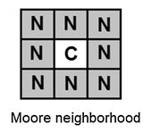

**Rule**

A cell occupied by oil would disperse to its neighbours, but the mass of the oil is always conserved according to the equation:

$$M_{i,j}^{t+1}= M_{i,j}^{t}+\left\{m\left[\left(M_{i-1,j}^{t}-M_{i,j}^{t}\right)+ \left(M_{i+1,j}^{t}-M_{i,j}^{t}\right)+ \left(M_{i,j+1}^{t}-M_{i,j}^{t}\right)+ \left(M_{i,j-1}^{t}-M_{i,j}^{t}\right)\right]\right\}+ \left\{md\left[\left(M_{i-1,j+1}^{t}-M_{i,j}^{t}\right)+ \left(M_{i+1,j+1}^{t}-M_{i,j}^{t}\right)+ \left(M_{i-1,j-1}^{t}-M_{i,j}^{t}\right)+ \left(M_{i+1,j-1}^{t}-M_{i,j}^{t}\right)\right]\right\}$$

Where,

$M_{y}^{x}$ is the oil mass in cell y at time x.

m is the spreading constant in the four adjacent cells.

d is the spreading constant for diagonal cells.

**Case 2: 2D oil spreading with the effect of wind/water current and vegetation present on water surface**

Fig. 2 represents a portion of the cell space under study. Each plane contains 10,000 cells (100*100). Which is zoned into two zones. One can think of each cell as a small fraction of the water body which is occupied by either water (0 of oil) or Crude oil (790) or a mixture of both oil and water (Greater than zero but less than 790) or vegetation (2000). The vegetation is zoned separately from the oil and water hence has a different set of rules for this simulation. All mass values are in Kilogram. The neighbourhood in this case considers the wind direction hence each cell has 6 neighbours (itself included). See figure 2.

The oil would spread in the direction of the wind/water current and avoid any existing vegetation in accordance to the rules stated below.

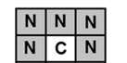

Figure 2: Neighborhood showing wind and water currents.

**Rule Zone 1.**

The oil disperses in the same direction as the wind/water current. A cell occupied by oil would disperse to its neighbours that contain water or a mixture of oil and water, but the mass of the oil is always conserved according to equation 2. In this case we consider the water current flowing from south to north.

$$M_{i,j}^{t+1}= M_{i,j}^{t}+\left\{m\left[\left(M_{i-1,j}^{t}-M_{i,j}^{t}\right)+ \left(M_{i+1,j}^{t}-M_{i,j}^{t}\right)\left(M_{i,j+1}^{t}-M_{i,j}^{t}\right)\right]\right\}+ \left\{md\left[\left(M_{i-1,j+1}^{t}-M_{i,j}^{t}\right)+ \left(M_{i+1,j+1}^{t}-M_{i,j}^{t}\right)\right]\right\}$$

**Rule Zone 2**

A cell containing vegetation would remain the same no matter what happens around it.

Where,

$M_{y}^{x}$ is the oil mass in cell y at time x.

m is the spreading constant in the four adjacent cells.

d is the spreading constant for diagonal cells.

**Case 3. 2D oil spreading with the effect of wind/water current and vegetation present on water surface.**

In this case the oil spill disperses based on the concepts discussed in case 1 above, but this case introduces complex vegetation.

**Case 4: 3D oil spill spreading with complex bathymetry**

In this case we simulate thee spread of an oil spill incorporating the rules above to different layers of water depth. The spread of the oil spill on the surface of the water body is similar to what has already been discussed in cases 1 and 2 above. However, in order to simulate the vertical movement of the oil spill (downward), we redefine the neighborhood as follows:

**Rule Zone (oil and water zones)**

A cell occupied by oil would disperse to its neighbours that contain water or a mixture of oil and water, but the mass of the oil is always conserved according to equation 3. Oil being dispersed will avoid other zones hence, different rules apply to other zones that contain vegetation. Same equations apply but in this case the neighbourhood is different because the cell in question would consider the cell above it in addition to those previously considered.

**Rule Vegetation Zones**

A cell containing vegetation would remain the same no matter what happens around it.

**IMPLEMENTATION**

**Case 1. 2D oil spreading without wind and current on surface**

The rules of this OilSpill model are defined based on the description given above.

Basic definitions for the model are given below:

**[top]**

**components : oilSpill**

**[oilSpill]**

**type : cell**

**dim : (100,100)**

**delay : transport**

**defaultDelayTime : 10**

**border : nonwrapped**

**neighbors : oilSpill(-1,-1) oilSpill(-1,0) oilSpill(-1,1)**

**neighbors : oilSpill(0,-1) oilSpill(0,0) oilSpill(0,1)**

**neighbors : oilSpill(1,-1) oilSpill(1,0) oilSpill(1,1)**

**initialvalue : 0**

**initialCellsValue : oil.val**

**localtransition : oilSpill**

**[oilSpill]**

**rule : {(0,0) + 0.098 * ((-1,0) - (0,0)) + 0.098 * ((1,0) - (0,0)) + 0.0176 * ((-1,1) - (0,0)) + 0.098 * ((0,1) - (0,0)) + 0.0176 * ((1,1) - (0,0)) + 0.0176 * ((-1,-1) - (0,0)) + 0.098 * ((0,-1) - (0,0)) + 0.0176 * ((1,-1) - (0,0))} 100 {(-1,0) > 0 or (1,0) > 0 or (-1,1) > 0 or (0,1) > 0 or (1,1) > 0 or (-1,-1) > 0 or (0,-1) > 0 or (1,-1) > 0}**

**rule : {(0,0)} 100 {t}**

**Case 2: 2D oil spreading with the effect of wind/water current and vegetation present on water surface**

The rules of this OilSpill model are defined based on the description given below. Simulation results would be shown for various variations of the initial values.

Basic definitions for the model are given below:

**[top]**

**components : OilSpill**

**[OilSpill]**

**type : cell**

**dim : (100,100)**

**delay : transport**

**defaultDelayTime : 10**

**border : nowrapped**

**neighbors : OilSpill(1,-1) OilSpill(1,0) OilSpill(1,1)**

**neighbors : OilSpill(0,-1) OilSpill(0,0) OilSpill(0,1)**

**%neighbors : OilSpill(-1,1) OilSpill(-1,-1) OilSpill(-1,0)**

**initialvalue : 0**

**initialCellsValue : OilSpill.val**

**localtransition : behavior**

**zone : island { (46,57)...(46,59) (47,47)...(47,59) (48,46)...(48,59) (49,45)...(49,59) (50,40)...(50,59) (51,40)...(51,59) (52,40)...(52,59) (53,41)...(53,59) (54,41)...(54,59) (55,42)...(55,58) (56,42)...(56,57) (57,43)...(57,52) }**

**[island]**

**%Rule for the green island cells**

**rule : {2000} 100 {t}**

**[behavior]**

**rule : {(0,0) + 0.098 * ((1,0) - (0,0)) + 0.098 * ((0,1) - (0,0)) + 0.0176 * ((1,1) - (0,0)) + 0.098 * ((0,-1) - (0,0)) + 0.0176 * ((1,-1) - (0,0))} 100 {((1,0) > 0 and (1,0) <=790) and ((0,1) > 0 and (0,1) <=790) and ((1,1) > 0 and (1,1) <=790) and ((0,-1) > 0 and (0,-1) <=790) and ((1,-1) > 0 and (1,-1) <=790)}**

**rule : {(0,0) + 0.098 * ((1,0) - (0,0)) + 0.098 * ((0,1) - (0,0)) + 0.0176 * ((1,1) - (0,0)) + 0.098 * ((0,-1) - (0,0)) + 0.0176 * ((1,-1) - (0,0))} 100 {((1,0) >= 0 and (1,0) != 2000) and ((0,1) >= 0 and (0,1) != 2000) and ((1,1) >= 0 and (1,1) != 2000) and ((0,-1) >= 0 and (0,-1) != 2000) and ((1,-1) >= 0 and (1,-1) != 2000)}**

**rule : {(0,0)} 10 {t}**

**Case 3: 2D oil spreading with the effect of complex vegetation present on water surface**

In this case, we use similar rules as obtained in case 1 above but we incorporated more zones to define a relatively complex vegetation on the water surface. The zones are as follows:

zone : island { (26,57,1)...(26,59,1) (27,47,1)...(27,59,1) (28,46,1)...(28,59,1) (29,45,1)...(29,59,1) (30,40,1)...(30,59,1) (31,40,1)...(31,59,1) (32,40,1)...(32,59,1) (33,41,1)...(33,59,1) (34,41,1)...(34,59,1) (35,42,1)...(35,58,1) (36,42,1)...(36,57,1) (37,43,1)...(37,52,1) }

zone : coastLine { (0,25,1)...(10,99,1) (11,29,1)...(11,42,1) (11,46,1)...(11,54,1) (11,58,1)...(11,69,1) (12,29,1)...(12,41,1) (12,47,1)...(12,53,1) (12,59,1)...(12,60,1) (12,62,1)...(12,63,1) (12,68,1)...(12,99,1) (13,30,1)...(13,40,1) (13,48,1)...(13,52,1) (13,71,1)...(13,99,1) (14,31,1)...(14,39,1) (14,49,1)...(14,51,1) (14,72,1)...(14,99,1) (15,32,1)...(15,38,1) (15,32,1)...(15,38,1) (15,73,1)...(15,99,1) (16,71,1)...(16,99,1) (17,72,1)...(17,99,1) (18,75,1)...(18,99,1) }

zone : coastLine0 { (19,76,1)...(19,99,1) (20,77,1)...(20,99,1) (21,16,1)...(21,20,1) (21,78,1)...(21,99,1) (22,15,1)...(22,21,1) (22,79,1)...(22,99,1) (23,13,1)...(23,22,1) (23,80,1)...(23,99,1) (24,13,1)...(24,23,1) (24,81,1)...(24,99,1) (25,13,1)...(25,23,1) (25,81,1)...(25,99,1) (26,12,1)...(26,25,1) (26,80,1)...(26,99,1) (27,10,1)...(27,27,1) (27,80,1)...(27,99,1) (28,8,1)...(28,27,1) (28,78,1)...(28,99,1) }

zone : coastLine1 { (29,7,1)...(29,28,1) (29,76,1)...(29,99,1) (30,5,1)...(30,28,1) (30,76,1)...(30,99,1) (31,3,1)...(31,30,1) (31,75,1)...(31,99,1) (32,1,1)...(32,30,1) (32,75,1)...(32,99,1) (33,0,1)...(33,27,1) (33,76,1)...(33,99,1) (34,0,1)...(34,26,1) (34,75,1)...(34,99,1) (35,0,1)...(35,25,1) (35,74,1)...(35,99,1) (36,0,1)...(36,23,1) (36,74,1)...(36,99,1) (37,0,1)...(37,22,1) (37,73,1)...(37,99,1) }

zone : coastLine2 { (38,0,1)...(38,21,1) (38,72,1)...(38,99,1) (39,0,1)...(39,19,1) (39,74,1)...(39,99,1) (40,0,1)...(40,18,1) (40,73,1)...(40,99,1) (41,0,1)...(41,18,1) (41,72,1)...(41,99,1) (42,0,1)...(42,15,1) (42,72,1)...(42,99,1) (43,0,1)...(43,14,1) (43,72,1)...(43,99,1) (44,0,1)...(44,12,1) (44,71,1)...(44,99,1) (45,0,1)...(45,10,1) (45,71,1)...(45,99,1) (46,0,1)...(46,10,1) (46,70,1)...(46,99,1) }

zone : coastLine3 { (47,0,1)...(47,8,1) (47,70,1)...(47,99,1) (48,0,1)...(48,10,1) (48,72,1)...(48,99,1) (49,0,1)...(49,10,1) (49,72,1)...(49,99,1) (50,0,1)...(50,11,1) (50,73,1)...(50,99,1) (51,0,1)...(51,12,1) (51,72,1)...(51,99,1) (52,0,1)...(52,8,1) (52,74,1)...(52,99,1) (53,0,1)...(53,9,1) (53,74,1)...(53,99,1) (54,0,1)...(54,9,1) (54,76,1)...(54,99,1) (55,0,1)...(55,9,1) }

zone : coastLine4 { (55,76,1)...(55,99,1) (56,0,1)...(56,9,1) (56,77,1)...(56,99,1) (57,0,1)...(57,9,1) (57,77,1)...(57,99,1) (58,0,1)...(58,8,1) (58,79,1)...(58,99,1) (59,0,1)...(59,8,1) (59,79,1)...(59,99,1) (60,0,1)...(60,7,1) (60,80,1)...(60,99,1) (61,0,1)...(61,7,1) (61,79,1)...(61,99,1) (62,0,1)...(62,7,1) (62,78,1)...(62,99,1) (63,0,1)...(63,7,1) }

zone : coastLine5 { (63,77,1)...(63,99,1) (64,0,1)...(64,7,1) (64,76,1)...(64,99,1) (65,0,1)...(65,7,1) (65,75,1)...(65,99,1) (66,0,1)...(66,8,1) (66,75,1)...(66,99,1) (67,0,1)...(67,8,1) (67,76,1)...(67,99,1) (68,0,1)...(68,8,1) (68,73,1)...(68,99,1) (69,0,1)...(69,9,1) (69,72,1)...(69,99,1) (70,0,1)...(70,10,1) (70,71,1)...(70,99,1) (71,0,1)...(71,11,1) (71,70,1)...(71,99,1) }

zone : coastLine6 { (72,0,1)...(72,12,1) (72,69,1)...(72,99,1) (73,0,1)...(73,13,1) (73,68,1)...(73,99,1) (74,0,1)...(74,20,1) (74,67,1)...(74,99,1) (75,0,1)...(75,21,1) (75,67,1)...(75,99,1) (76,0,1)...(76,22,1) (76,67,1)...(76,99,1) (77,0,1)...(77,23,1) (77,67,1)...(77,99,1) (78,0,1)...(78,23,1) (78,68,1)...(78,99,1) (79,0,1)...(79,23,1) (79,69,1)...(79,99,1) (80,0,1)...(80,23,1) }

zone : coastLine7 { (80,70,1)...(80,99,1) (81,0,1)...(81,23,1) (81,70,1)...(81,99,1) (82,0,1)...(82,23,1) (82,68,1)...(82,99,1) (83,0,1)...(83,23,1) (83,68,1)...(83,99,1) (84,0,1)...(84,24,1) (84,70,1)...(84,99,1) (85,0,1)...(85,25,1) (85,77,1)...(85,99,1) (86,0,1)...(86,25,1) (86,69,1)...(86,99,1) (87,0,1)...(87,26,1) (87,69,1)...(87,99,1) (88,0,1)...(88,27,1) }

zone : coastLine8 { (88,68,1)...(88,99,1) (89,0,1)...(89,28,1) (89,67,1)...(89,99,1) (90,0,1)...(90,29,1) (90,66,1)...(90,99,1) (91,0,1)...(91,30,1) (91,68,1)...(91,99,1) (92,0,1)...(92,31,1) (92,67,1)...(92,99,1) (93,0,1)...(93,32,1) (93,66,1)...(93,99,1) (94,0,1)...(94,32,1) (94,67,1)...(94,99,1) (95,0,1)...(95,32,1) (95,68,1)...(95,99,1) (96,0,1)...(96,32,1) }

zone : coastLine9 { (96,69,1)...(96,99,1) (97,0,1)...(97,33,1) (97,71,1)...(97,99,1) (98,0,1)...(98,34,1) (98,71,1)...(98,99,1) (99,0,1)...(99,35,1) (99,72,1)...(99,99,1) }

[island]

%Rule for the green island cells

rule : {2000} 100 {t}

[coastLine]

%Rule for the green coastLine cells

rule : {2000} 100 {t}

[coastLine0]

%Rule for the green coastLine cells

rule : {2000} 100 {t}

[coastLine1]

%Rule for the green coastLine cells

rule : {2000} 100 {t}

[coastLine2]

%Rule for the green coastLine cells

rule : {2000} 100 {t}

[coastLine3]

%Rule for the green coastLine cells

rule : {2000} 100 {t}

[coastLine4]

%Rule for the green coastLine cells

rule : {2000} 100 {t}

[coastLine5]

%Rule for the green coastLine cells

rule : {2000} 100 {t}

[coastLine6]

%Rule for the green coastLine cells

rule : {2000} 100 {t}

[coastLine7]

%Rule for the green coastLine cells

rule : {2000} 100 {t}

[coastLine8]

%Rule for the green coastLine cells

rule : {2000} 100 {t}

[coastLine9]

%Rule for the green coastLine cells

rule : {2000} 100 {t}

**Case 4: 3D oil spreading with vegetation present on water surface**

In this case, the oil is assumed to have spilled on the second level (10m) below the water surface and this area has vegetation present. We simulate the oil spread as a result of forces preciously considered as well as downward vertical movements to levels beyond the surface. Level 0 = water surface, level 1 = 10m level 2 = 20m and level 3 = 30m below the water surface.

[top]

components : OilSpill

[OilSpill]

type : cell

dim : (100,100,4)

delay : transport

defaultDelayTime : 10

border : nowrapped

neighbors : OilSpill(-1,-1,0) OilSpill(-1,0,0) OilSpill(-1,1,0)

neighbors : OilSpill(0,-1,0) OilSpill(0,0,0) OilSpill(0,1,0)

neighbors : OilSpill(1,-1,0) OilSpill(1,0,0) OilSpill(1,1,0)

neighbors : OilSpill(-1,-1,1) OilSpill(-1,0,1) OilSpill(-1,1,1)

neighbors : OilSpill(0,-1,1) OilSpill(0,0,1) OilSpill(0,1,1)

neighbors : OilSpill(1,-1,1) OilSpill(1,0,1) OilSpill(1,1,1)

neighbors : OilSpill(0,0,-1)

initialvalue : 0

initialCellsValue : OilSpill3D.val

localtransition : OilBehavior

zone : island { (26,57,1)...(26,59,1) (27,47,1)...(27,59,1) (28,46,1)...(28,59,1) (29,45,1)...(29,59,1) (30,40,1)...(30,59,1) (31,40,1)...(31,59,1) (32,40,1)...(32,59,1) (33,41,1)...(33,59,1) (34,41,1)...(34,59,1) (35,42,1)...(35,58,1) (36,42,1)...(36,57,1) (37,43,1)...(37,52,1) }

zone : coastLine { (0,25,1)...(10,99,1) (11,29,1)...(11,42,1) (11,46,1)...(11,54,1) (11,58,1)...(11,69,1) (12,29,1)...(12,41,1) (12,47,1)...(12,53,1) (12,59,1)...(12,60,1) (12,62,1)...(12,63,1) (12,68,1)...(12,99,1) (13,30,1)...(13,40,1) (13,48,1)...(13,52,1) (13,71,1)...(13,99,1) (14,31,1)...(14,39,1) (14,49,1)...(14,51,1) (14,72,1)...(14,99,1) (15,32,1)...(15,38,1) (15,32,1)...(15,38,1) (15,73,1)...(15,99,1) (16,71,1)...(16,99,1) (17,72,1)...(17,99,1) (18,75,1)...(18,99,1) }

zone : coastLine0 { (19,76,1)...(19,99,1) (20,77,1)...(20,99,1) (21,16,1)...(21,20,1) (21,78,1)...(21,99,1) (22,15,1)...(22,21,1) (22,79,1)...(22,99,1) (23,13,1)...(23,22,1) (23,80,1)...(23,99,1) (24,13,1)...(24,23,1) (24,81,1)...(24,99,1) (25,13,1)...(25,23,1) (25,81,1)...(25,99,1) (26,12,1)...(26,25,1) (26,80,1)...(26,99,1) (27,10,1)...(27,27,1) (27,80,1)...(27,99,1) (28,8,1)...(28,27,1) (28,78,1)...(28,99,1) }

zone : coastLine1 { (29,7,1)...(29,28,1) (29,76,1)...(29,99,1) (30,5,1)...(30,28,1) (30,76,1)...(30,99,1) (31,3,1)...(31,30,1) (31,75,1)...(31,99,1) (32,1,1)...(32,30,1) (32,75,1)...(32,99,1) (33,0,1)...(33,27,1) (33,76,1)...(33,99,1) (34,0,1)...(34,26,1) (34,75,1)...(34,99,1) (35,0,1)...(35,25,1) (35,74,1)...(35,99,1) (36,0,1)...(36,23,1) (36,74,1)...(36,99,1) (37,0,1)...(37,22,1) (37,73,1)...(37,99,1) }

zone : coastLine2 { (38,0,1)...(38,21,1) (38,72,1)...(38,99,1) (39,0,1)...(39,19,1) (39,74,1)...(39,99,1) (40,0,1)...(40,18,1) (40,73,1)...(40,99,1) (41,0,1)...(41,18,1) (41,72,1)...(41,99,1) (42,0,1)...(42,15,1) (42,72,1)...(42,99,1) (43,0,1)...(43,14,1) (43,72,1)...(43,99,1) (44,0,1)...(44,12,1) (44,71,1)...(44,99,1) (45,0,1)...(45,10,1) (45,71,1)...(45,99,1) (46,0,1)...(46,10,1) (46,70,1)...(46,99,1) }

zone : coastLine3 { (47,0,1)...(47,8,1) (47,70,1)...(47,99,1) (48,0,1)...(48,10,1) (48,72,1)...(48,99,1) (49,0,1)...(49,10,1) (49,72,1)...(49,99,1) (50,0,1)...(50,11,1) (50,73,1)...(50,99,1) (51,0,1)...(51,12,1) (51,72,1)...(51,99,1) (52,0,1)...(52,8,1) (52,74,1)...(52,99,1) (53,0,1)...(53,9,1) (53,74,1)...(53,99,1) (54,0,1)...(54,9,1) (54,76,1)...(54,99,1) (55,0,1)...(55,9,1) }

zone : coastLine4 { (55,76,1)...(55,99,1) (56,0,1)...(56,9,1) (56,77,1)...(56,99,1) (57,0,1)...(57,9,1) (57,77,1)...(57,99,1) (58,0,1)...(58,8,1) (58,79,1)...(58,99,1) (59,0,1)...(59,8,1) (59,79,1)...(59,99,1) (60,0,1)...(60,7,1) (60,80,1)...(60,99,1) (61,0,1)...(61,7,1) (61,79,1)...(61,99,1) (62,0,1)...(62,7,1) (62,78,1)...(62,99,1) (63,0,1)...(63,7,1) }

zone : coastLine5 { (63,77,1)...(63,99,1) (64,0,1)...(64,7,1) (64,76,1)...(64,99,1) (65,0,1)...(65,7,1) (65,75,1)...(65,99,1) (66,0,1)...(66,8,1) (66,75,1)...(66,99,1) (67,0,1)...(67,8,1) (67,76,1)...(67,99,1) (68,0,1)...(68,8,1) (68,73,1)...(68,99,1) (69,0,1)...(69,9,1) (69,72,1)...(69,99,1) (70,0,1)...(70,10,1) (70,71,1)...(70,99,1) (71,0,1)...(71,11,1) (71,70,1)...(71,99,1) }

zone : coastLine6 { (72,0,1)...(72,12,1) (72,69,1)...(72,99,1) (73,0,1)...(73,13,1) (73,68,1)...(73,99,1) (74,0,1)...(74,20,1) (74,67,1)...(74,99,1) (75,0,1)...(75,21,1) (75,67,1)...(75,99,1) (76,0,1)...(76,22,1) (76,67,1)...(76,99,1) (77,0,1)...(77,23,1) (77,67,1)...(77,99,1) (78,0,1)...(78,23,1) (78,68,1)...(78,99,1) (79,0,1)...(79,23,1) (79,69,1)...(79,99,1) (80,0,1)...(80,23,1) }

zone : coastLine7 { (80,70,1)...(80,99,1) (81,0,1)...(81,23,1) (81,70,1)...(81,99,1) (82,0,1)...(82,23,1) (82,68,1)...(82,99,1) (83,0,1)...(83,23,1) (83,68,1)...(83,99,1) (84,0,1)...(84,24,1) (84,70,1)...(84,99,1) (85,0,1)...(85,25,1) (85,77,1)...(85,99,1) (86,0,1)...(86,25,1) (86,69,1)...(86,99,1) (87,0,1)...(87,26,1) (87,69,1)...(87,99,1) (88,0,1)...(88,27,1) }

zone : coastLine8 { (88,68,1)...(88,99,1) (89,0,1)...(89,28,1) (89,67,1)...(89,99,1) (90,0,1)...(90,29,1) (90,66,1)...(90,99,1) (91,0,1)...(91,30,1) (91,68,1)...(91,99,1) (92,0,1)...(92,31,1) (92,67,1)...(92,99,1) (93,0,1)...(93,32,1) (93,66,1)...(93,99,1) (94,0,1)...(94,32,1) (94,67,1)...(94,99,1) (95,0,1)...(95,32,1) (95,68,1)...(95,99,1) (96,0,1)...(96,32,1) }

zone : coastLine9 { (96,69,1)...(96,99,1) (97,0,1)...(97,33,1) (97,71,1)...(97,99,1) (98,0,1)...(98,34,1) (98,71,1)...(98,99,1) (99,0,1)...(99,35,1) (99,72,1)...(99,99,1) }

[island]

%Rule for the green island cells

rule : {2000} 100 {t}

[coastLine]

%Rule for the green coastLine cells

rule : {2000} 100 {t}

[coastLine0]

%Rule for the green coastLine cells

rule : {2000} 100 {t}

[coastLine1]

%Rule for the green coastLine cells

rule : {2000} 100 {t}

[coastLine2]

%Rule for the green coastLine cells

rule : {2000} 100 {t}

[coastLine3]

%Rule for the green coastLine cells

rule : {2000} 100 {t}

[coastLine4]

%Rule for the green coastLine cells

rule : {2000} 100 {t}

[coastLine5]

%Rule for the green coastLine cells

rule : {2000} 100 {t}

[coastLine6]

%Rule for the green coastLine cells

rule : {2000} 100 {t}

[coastLine7]

%Rule for the green coastLine cells

rule : {2000} 100 {t}

[coastLine8]

%Rule for the green coastLine cells

rule : {2000} 100 {t}

[coastLine9]

%Rule for the green coastLine cells

rule : {2000} 100 {t}

[OilBehavior]

rule : {(0,0,0) + 0.098 * ((0,0,-1) - (0,0,0)) + 0.098 * ((1,0,0) - (0,0,0)) + 0.098 * ((0,1,0) - (0,0,0)) + 0.0176 * ((1,1,0) - (0,0,0)) + 0.098 * ((0,-1,0) - (0,0,0)) + 0.0176 * ((1,-1,0) - (0,0,0)) + 0.0176 * ((-1,1,0) - (0,0,0)) + 0.098 * ((-1,0,0) - (0,0,0)) + 0.0176 * ((-1,-1,0) - (0,0,0))} 100 {((1,0,0) > 0 and (1,0,0) <=790) and ((0,1,0) > 0 and (0,1,0) <=790) and ((1,1,0) > 0 and (1,1,0) <=790) and ((0,-1,0) > 0 and (0,-1,0) <=790) and ((1,-1,0) > 0 and (1,-1,0) <=790) and ((-1,1,0) > 0 and (-1,1,0) <=790) and ((-1,0,0) > 0 and (-1,0,0) <=790) and ((-1,-1,0) > 0 and (-1,-1,0) <=790) and ((0,0,-1) > 0 and ((0,0,-1) <=790)}

rule : {(0,0,0) + 0.098 * ((0,0,-1) - (0,0,0)) + 0.098 * ((1,0,0) - (0,0,0)) + 0.098 * ((0,1,0) - (0,0,0)) + 0.0176 * ((1,1,0) - (0,0,0)) + 0.098 * ((0,-1,0) - (0,0,0)) + 0.0176 * ((1,-1,0) - (0,0,0)) + 0.0176 * ((-1,1,0) - (0,0,0)) + 0.098 * ((-1,0,0) - (0,0,0)) + 0.0176 * ((-1,-1,0) - (0,0,0))} 100 {((1,0,0) >= 0 and (1,0,0) != 2000) and ((0,1,0) >= 0 and (0,1,0) != 2000) and ((1,1,0) >= 0 and (1,1,0) != 2000) and ((0,-1,0) >= 0 and (0,-1,0) != 2000) and ((1,-1,0) >= 0 and (1,-1,0) != 2000) and ((-1,1,0) >= 0 and (-1,1,0) != 2000) and ((-1,0,0) >= 0 and (-1,0,0) != 2000) and ((-1,-1,0) >= 0 and (-1,-1,0) != 2000) and ((0,0,-1) >= 0 and ((0,0,-1) != 2000)}

rule : {(0,0,0)} 10 {t}

**SIMULATION RESULTS**

The simulation results are shown below. The images on the left correspond to the initial state of the cells before simulation while those on the right correspond to the state after simulating after some time.

**-COLOR PALLET DESCRIPTION**

*The following color specification describe the cases and occurrences in the pictures:*

*Blue: represents the water body*

*Black: represents the crude oil between its maximum mass of 790mg and 20% below its maximum mass.*

*Grey: represents the crude oil between the mass of 632mg and 20% below 632mg.*

*Ash: represents the crude oil mass below 508mg.*

*Green: represents the thick vegetation on top of the water body.*

**Case 1. 2D oil spreading without wind and current on surface**

On the left side on figure below shows the initial

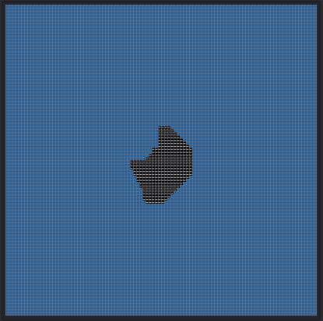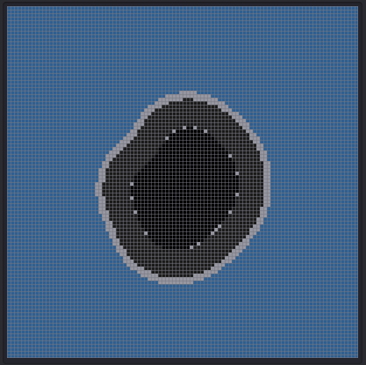

**Figure 3:** Simulation results for case 1 showing initial condition and simulation after 5seconds

**Case 2: 2D oil spreading with the effect of wind/water current and vegetation present on water surface**

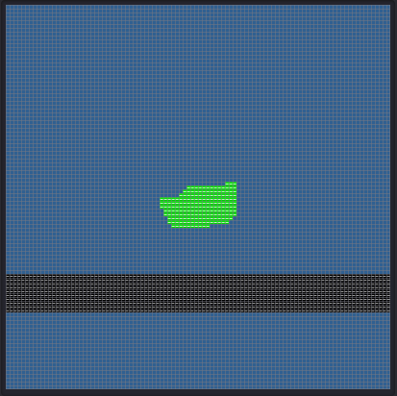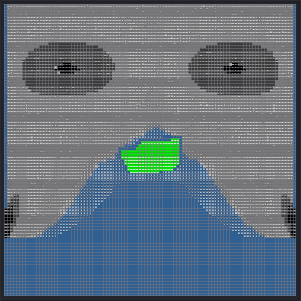

**Figure 4:** Simulation results for case 2 showing initial condition and simulation after 10 seconds

**Case 3: 2D oil spreading with the effect of complex vegetation present on water surface**

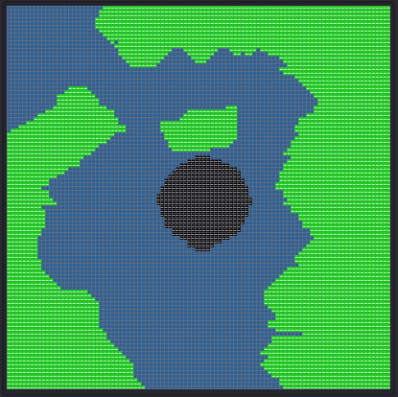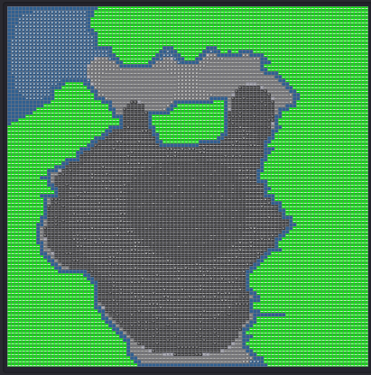

**Figure 5:** Simulation results for case 3 showing initial condition and simulation after 30 seconds

**Case 4: 3D oil spreading with the effect vegetation present on water surface**

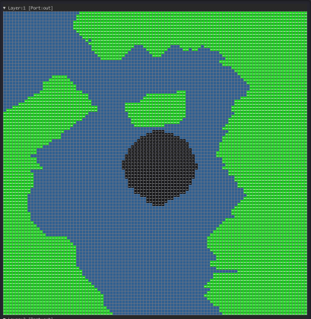 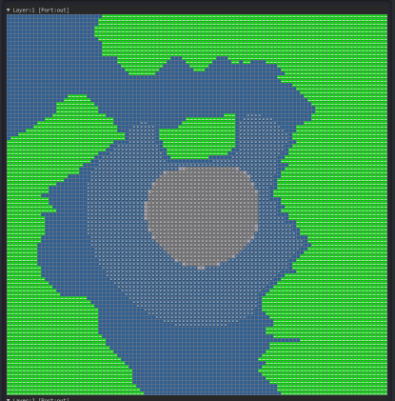

**Figure 5:** Simulation results for case 3 layer 1 showing initial condition and simulation after 10 seconds

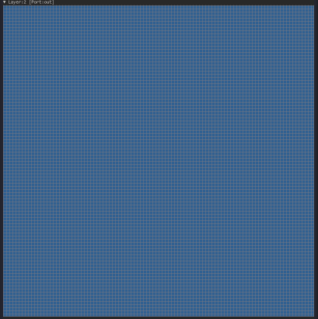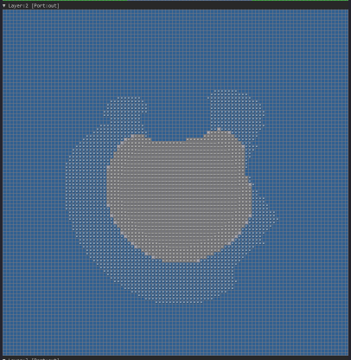

**Figure 6:** Simulation results for case 3 layer 2 showing initial condition and simulation after 10 seconds

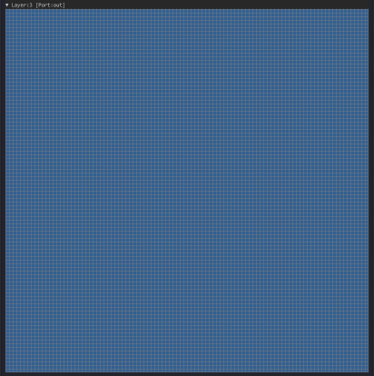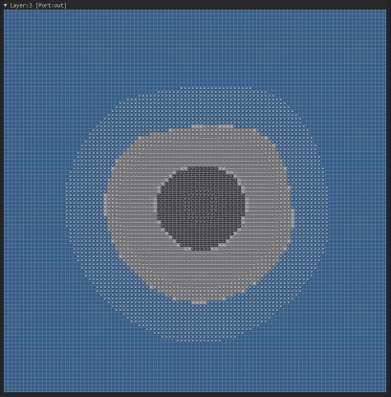

**Figure 7:** Simulation results for case 3 layer 3 showing initial condition and simulation after 10 seconds